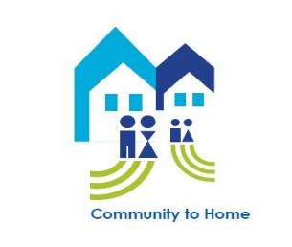
Community to Home
Are you the parent/caregiver of a child with special health care needs or think your child may need to be evaluated for services?
Do you feel frustrated or not sure where to turn?
Do you know all the services available to you?
Who we are: CareStar and Health Promotion Council are two agencies that provide free home-visiting services to Pennsylvania families of at-risk children or children already diagnosed with a special health care need. This program is called Community to Home.
Through Community to Home, we provide the following services:
- Family-centered home visits.
- Linkages to community resources.
- Support in understanding child’s health and development.
- Roadmaps to self-sufficiency considering unique family needs.
- Culturally sensitive and linguistically appropriate social support.
- Liaison between individuals, families/caregivers, health care and service providers.
- Attendance to appointments, including Individualized Education Program (IEP) meetings, doctor appointments and benefit meetings.
- And much more!

Health Promotion Council serves residents of Adams, Blair, Franklin, Fulton, Huntingdon, Juniata, Mifflin and Perry counties.
Need Help? Call the Health Promotion Council today at: 717.512.6888
CareStar serves residents of Armstrong, Bedford, Bradford, Butler Cambria, Cameron, Carbon, Centre, Clarion, Clearfield, Clinton, Columbia, Crawford, Elk, Fayette, Forest, Greene, Indiana, Jefferson, Somerset, McKean, Mercer, Monroe, Pike, Potter, Schuylkill, Snyder, Montour, Sullivan, Susquehanna, Tioga, Union, Venango, Warren, Washington, Wayne and Wyoming counties.
Need Help? Call CareStar today at: 1.800.616.8319

Community to Home is funded by the Pennsylvania Department of Health.

